Agent-Based Prototype for Phishing Detection in the field of Health Enquiries

Course: COMP248 – AI Systems Design
Group # 1
Submitted By: Michael Del Rosario
Marc Harty
Josias Ndam Mefire
Instructor: Hakim Klif

Contents
1. Rationale and Scope 2
2. Research Results Specified in Deliverables 3
2.1 Agent Workflow Summary 3
2.2 Tools the Agent Uses 3
2.3 Knowledge Base Design (Aligned to Real CSV) 4
2.4 Governance and Compliance Hooks 4
3. Design Documents 5
3.1 Architecture Diagram 5
3.2 UML Class Diagram 7
3.3 Sequence Diagram 8
3.4 Data Model 8
3.5 Prototype Functionality Summary 8
4. Conclusion 9
5. Assumptions 9
6. References 9
Appendix 1: Meeting Register 10

Rationale and Scope

Through​‍​‌‍​‍‌ the creation and actualization of an automated AI that can simply comprehend a phishing-classified email, and consequently, upgrade a RedFlag-local Knowledge Base (KB) without human intervention, is at the core of this initiative the demonstration of the functionality or the simulation of the modus operandi of an agentic system, the latter being conceived as a support to and the enhancement of the efficiency of the security teams, by early recognizing the new wave of phishing, as well as by regularly keeping the historical data of fraudulent ​‍​‌‍​‍‌sources.
The scope of the project includes:
- Loading daily classified email CSV files
- Filtering phishing emails
- Extracting suspicious patterns from subject and body fields using a keyword-based heuristic
- Checking which patterns are already known (stored in the KB)
- Appending newly detected red flags to the KB using the same three-column structure found in the historical dataset
- Printing before and after snapshots to demonstrate transparency and auditability
- Producing accompanying design documentation including UML, architecture diagrams, and data models
This system does not attempt to classify the emails itself or use advanced NLP models; rather, it focuses on demonstrating agent workflow, tool invocation, structured data handling, and explainability.

Research Results Specified in Deliverables

Agent Workflow Summary
The agent, called Genius, performs a sequential workflow:
- Load the daily email dataset produced by an external ML classifier.
- Filter emails where label == 1 (phishing).
- Load the existing Red Flag Knowledge Base, which tracks historical phishing indicators.
- Use the SimplePatternHeuristic tool to detect suspicious phrases.
- Compare detected patterns to existing patterns in the KB.
- Append new indicators to the KB with proper timestamps.
- Print a before-and-after view of the KB to demonstrate the update.
This workflow meets the assignment requirement for a “super agent” performing a clear sequence of tasks with defined tools.

Tools the Agent Uses
CSV Reader (EmailDatasetReader)
- Reads daily email CSV
- Performs schema validation
- Filters phishing emails
Pattern Detection Tool (SimplePatternHeuristic)
- Searches for predefined suspicious phrases
- Detects whether patterns occur in email subject or body
- Returns structured candidate red flags
Knowledge Base Access Tool (RedFlagStore)
- Loads existing KB
- Compares candidate red flags against existing entries
- Writes new entries when needed
These three tools allow the agent to perform the assignment’s required combination of search, compare, retrieve, and update operations.

Knowledge Base Design (Aligned to Real CSV)
The knowledge base, stored in Red Flag.csv, follows a simple three-column format:
Field Name | Description
Location | Indicates whether pattern was found in the subject or body
Red Flag | The suspicious phrase or content
Date Identified | Timestamp formatted as: Tuesday, 05 Sep 2006 10:31:02 -0705

This KB serves as the agent’s memory allowing it to avoid rediscovering the same phishing patterns.

Governance and Compliance Hooks
The system includes several governance features:
- Human-readable outputs: CSV and terminal prints make updates transparent.
- Before/After snapshots: Executions show precisely what changed.
- Explainability: Heuristic-based rules keep detection deterministic.
- Traceability: Each new red flag includes timestamp and email location.
- No autonomous actions: System does not classify or send communications—only documents patterns.
These elements meet responsible agent system design standards.

Design Documents

Architecture Diagram

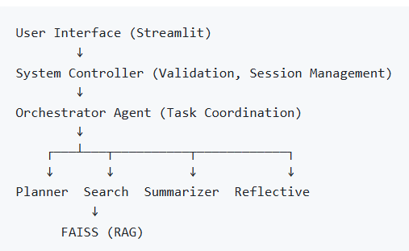

The​‍​‌‍​‍‌ system architecture is structured like a multi-layered, agentic system, where each part has a definite function but is still working in a coordinated flow. On the topmost level, the User Interface, which is realized by Streamlit, is the layer of interaction. This is the place where the users input their questions, means of analyses are triggered, and the responses produced are inspected. The interface is made to be very user-friendly so that the user doesn't have to know about the complexity of the agentic workflow which is hidden behind a neat and easily accessible front end. Directly below the UI, there is the System Controller that takes care of input validation, user sessions management, and the implementation of constraints for stable interaction. The gatekeeper function of this controller is to ensure that only well-formed requests go to the agentic system which is at the core. Besides that, the controller also stops the invalid sequences of operations and at the same time keeps the continuity of the user interactions.
The subsequent layer is that of the Orchestrator Agent, which is endowed with the function of being the central coordinator of intention all the downstream agent activities. The orchestrator, among other things, understands the user's objective, it decides what has to be activated, and it also arranges the work with specialized agents in a correct way. The orchestrator is not a domain task performer, but a task manager and a workflow executor instead.
Below the orchestrator there is a set of specialized agents, and each one is uniquely crafted for a single specific operational role:
- Planner Agent – Handles elaborative query from the user by picturing it in the form of structured incomplete tasks and recognizes necessary steps of the action sequence.
- Search Agent – Uses FAISS for vector search to get relevant information for retrieval-augmented generation (RAG).
- Summarizer Agent – Takes the retrieved or produced content and makes it into easy-to-understand, logical summaries meant for the user’s context.
- Reflective Agent – Looks at the previous work, finds the missing places or mistakes, and then by self-critique, it gradually perfects the output.
These agents together use a common knowledge retrieval layer, which is powered by FAISS (RAG) for that matter. This is a vector-based retrieval system that makes it possible for a very efficient semantic search to be carried out over large corpora. Thus, the agents can base their reasoning on what is stored rather than on what is generated.
In essence, this architecture is the basis for the system’s modularity, interpretability, and extensibility. The rationale behind each layer is a different one—interface, control, orchestration, specialized reasoning, and retrieval—working as a whole group of cooperating agents, the system is capable of complex, multi-step reasoning while being transparent and under user's ​‍​‌‍​‍‌control.

UML Class Diagram
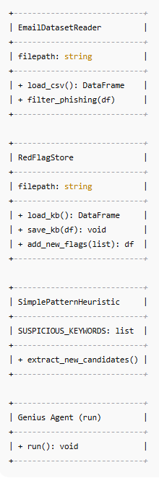

Sequence Diagram

Data Model
Email Data Set
Column | Description
sender | Email sender
receiver | Email receiver
date | Date and time received
subject | Email subject text
body | Email body text
label | ML-classified phishing indicator (0 or 1)

Red Flag KB
Column | Description
Location | Subject or body
Red Flag | Suspicious phrase
Date Identified | Timestamp

Prototype Functionality Summary
The implemented prototype demonstrates:
- End-to-end automated data ingestion
- Identification of phishing patterns
- Consistent, deterministic pattern extraction
- Knowledge base updates with correct formatting
- Governance through transparent before/after logging

Conclusion
The phishing detection agent successfully performs all assigned tasks: reading datasets, detecting new suspicious patterns, updating a knowledge base, and producing transparent trace logs. While simple, this prototype demonstrates the core principles of agentic system design, including tool use, deterministic workflows, explainability, and human oversight. The project shows how rule-based agents can complement machine learning outputs by maintaining updated threat intelligence resources.

Assumptions
- The ML classifier providing the daily email file is considered accurate and outside the scope of this prototype.
- Only keyword-based suspicious indicators were required for this assignment.
- All CSV files are in the same working directory as the script.
- The timestamp format must match the legacy style shown in the dataset.
- No complex NLP or LLM models were required or used.
- The system runs on a local machine with Python and pandas installed.

References
OpenAI. (2023). GPT models and agentic system design principles.
Centennial College. (2025). COMP 248 Assignment 3 Instructions.
Jurafsky, D., & Martin, J. (2021). Speech and Language Processing (3rd ed.).
Phishing Email Dataset (Anonymous). Provided by course materials.

Appendix 1: Meeting Register

Date | Time | Attendees | Topics | Action Items
10/29/2025 | 2:30 PM | Michael Del Rosario  Marc Harty  Josias Ndam Mefire | Project Team Assembled | Study Project Assignment Document
11/3/2025 | 4:30 PM | Michael Del Rosario  Marc Harty  Josias Ndam Mefire | Assignment of Tasks | Architecture Design – Michael  UML Class Design – Marc  Design Draft Document -Josias
11/10/2025 | 4:30 PM | Michael Del Rosario  Marc Harty  Josias Ndam Mefire | Continue Tasks assigned | Architecture Design – Michael  UML Class Design – Marc  Design Draft Document -Josias
11/17/2025 | 2:30 PM | Michael Del Rosario  Josias Ndam Mefire | Design Review | Discussed Design Draft in class
11/24/2025 | 2:30 PM | Michael Del Rosario  Josias Ndam Mefire | Prototype Review | Discussed Prototype in class
12/8/2025 | 2:30 PM | Michael Del Rosario  Marc Harty  Josias Ndam Mefire | Presentation, prototype demonstrations, and individual assessments. | Submission and presentation of project

